
AI Assignment 5
Dr. Rabia Maqsood

waleed nadeem
23F-0628
BCS-6A

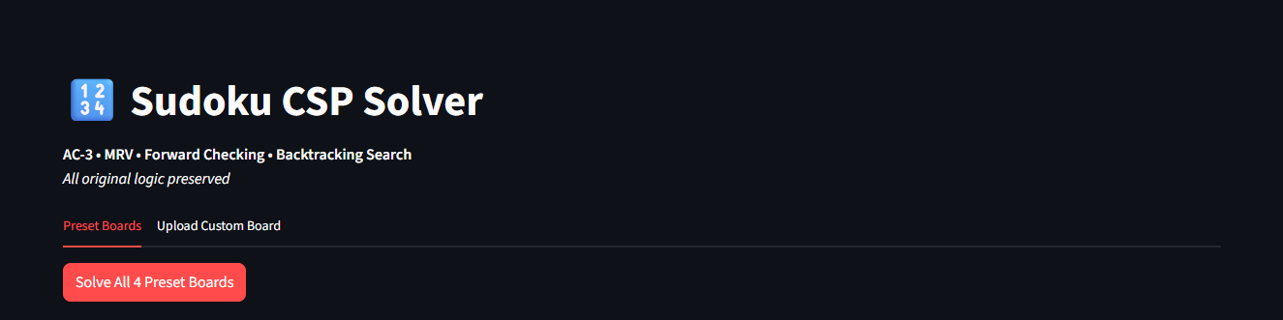
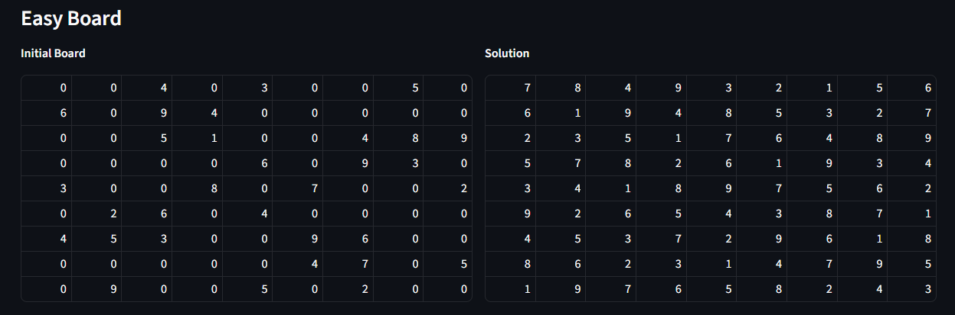
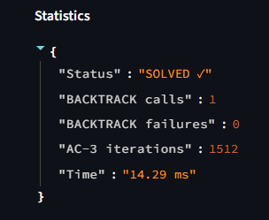
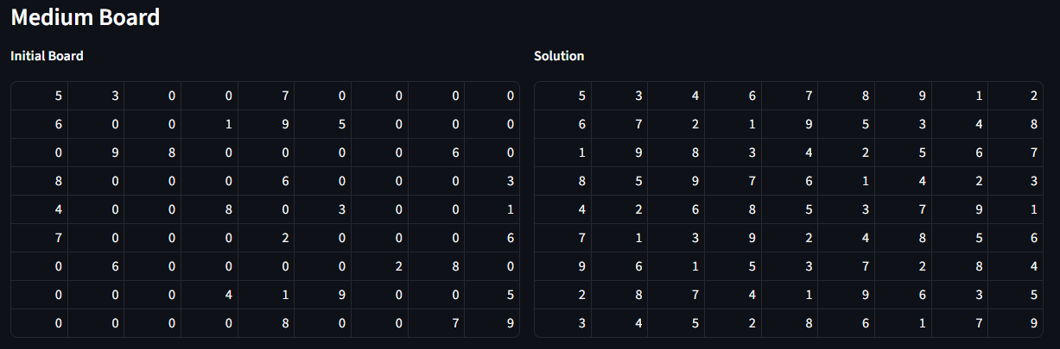
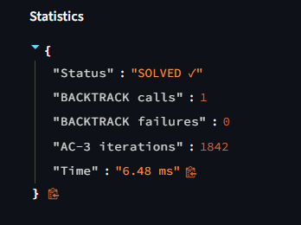
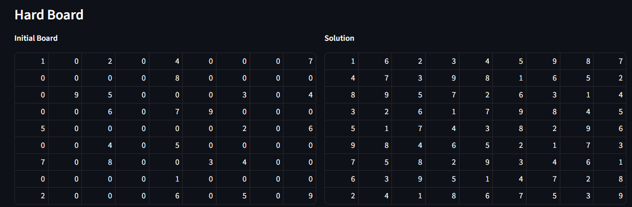
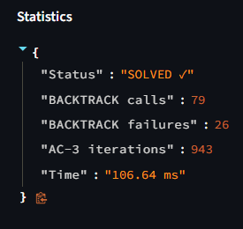
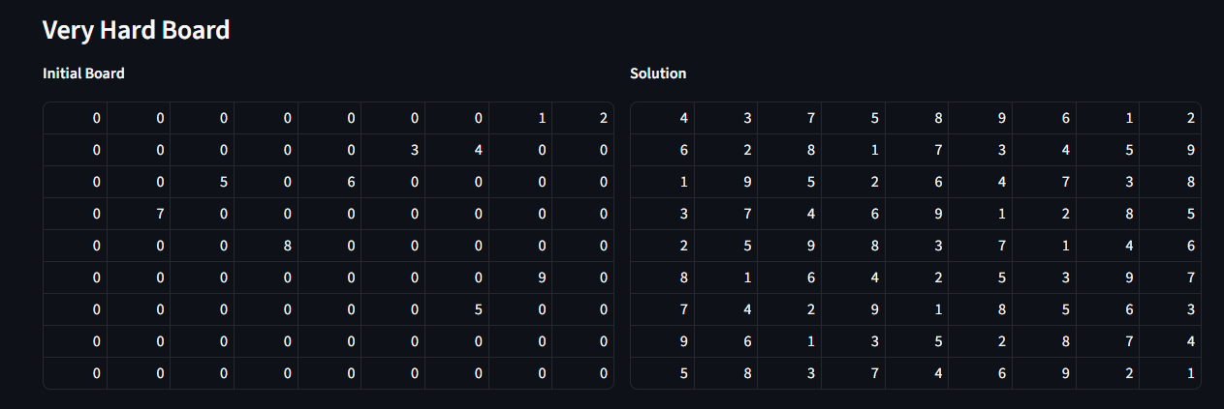
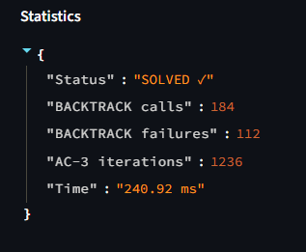
How to run?
PS C:\Users\walee\Downloads\AI_Assignment_5> python -m streamlit run sudoku_csp_web.py
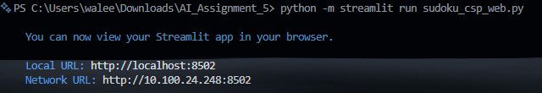
Code:
import streamlit as st
import copy
import time
from collections import deque

st.set_page_config(page_title="Sudoku CSP Solver", layout="wide")
st.title("🔢 Sudoku CSP Solver")
st.markdown("**AC-3 • MRV • Forward Checking • Backtracking Search** \n*All original logic preserved*")

# ====================== PRESETS ======================
PRESETS = {
"easy": {"name": "Easy Board", "data": [[0,0,4,0,3,0,0,5,0],[6,0,9,4,0,0,0,0,0],[0,0,5,1,0,0,4,8,9],[0,0,0,0,6,0,9,3,0],[3,0,0,8,0,7,0,0,2],[0,2,6,0,4,0,0,0,0],[4,5,3,0,0,9,6,0,0],[0,0,0,0,0,4,7,0,5],[0,9,0,0,5,0,2,0,0]]},
"medium": {"name": "Medium Board", "data": [[5,3,0,0,7,0,0,0,0],[6,0,0,1,9,5,0,0,0],[0,9,8,0,0,0,0,6,0],[8,0,0,0,6,0,0,0,3],[4,0,0,8,0,3,0,0,1],[7,0,0,0,2,0,0,0,6],[0,6,0,0,0,0,2,8,0],[0,0,0,4,1,9,0,0,5],[0,0,0,0,8,0,0,7,9]]},
"hard": {"name": "Hard Board", "data": [[1,0,2,0,4,0,0,0,7],[0,0,0,0,8,0,0,0,0],[0,9,5,0,0,0,3,0,4],[0,0,6,0,7,9,0,0,0],[5,0,0,0,0,0,2,0,6],[0,0,4,0,5,0,0,0,0],[7,0,8,0,0,3,4,0,0],[0,0,0,0,1,0,0,0,0],[2,0,0,0,6,0,5,0,9]]},
"veryhard": {
"name": "Very Hard Board",
"data": [
[0,0,0,0,0,0,0,1,2],
[0,0,0,0,0,3,4,0,0],
[0,0,5,0,6,0,0,0,0],
[0,7,0,0,0,0,0,0,0],
[0,0,0,8,0,0,0,0,0],
[0,0,0,0,0,0,0,9,0],
[0,0,0,0,0,0,5,0,0],
[0,0,0,0,0,0,0,0,0],
[0,0,0,0,0,0,0,0,0]
]
}
}

# ====================== CORE SOLVER (Your Original Logic) ======================
def _compute_peers(r, c):
peers = set()
for i in range(9):
if i != c: peers.add((r, i))
if i != r: peers.add((i, c))
br, bc = (r // 3) * 3, (c // 3) * 3
for dr in range(3):
for dc in range(3):
nb = (br + dr, bc + dc)
if nb != (r, c): peers.add(nb)
return frozenset(peers)

PEERS = {(r, c): _compute_peers(r, c) for r in range(9) for c in range(9)}

def build_domains(board):
domains = {}
for r in range(9):
for c in range(9):
if board[r][c] != 0:
domains[(r, c)] = {board[r][c]}
else:
used = {board[pr][pc] for (pr, pc) in PEERS[(r, c)] if board[pr][pc] != 0}
domains[(r, c)] = set(range(1, 10)) - used
return domains

def ac3(board, domains):
queue = deque([(r, c, pr, pc) for r in range(9) for c in range(9) if board[r][c] == 0
for (pr, pc) in PEERS[(r, c)] if board[pr][pc] == 0])
arc_iterations = 0
while queue:
r1, c1, r2, c2 = queue.popleft()
arc_iterations += 1
if _revise(domains, r1, c1, r2, c2):
if not domains[(r1, c1)]:
return False, arc_iterations
for (pr, pc) in PEERS[(r1, c1)]:
if (pr, pc) != (r2, c2) and board[pr][pc] == 0:
queue.append((pr, pc, r1, c1))
return True, arc_iterations

def _revise(domains, r1, c1, r2, c2):
revised = False
for v in list(domains[(r1, c1)]):
if not any(w != v for w in domains[(r2, c2)]):
domains[(r1, c1)].discard(v)
revised = True
return revised

def select_mrv(board, domains):
best, best_size = None, 10
for r in range(9):
for c in range(9):
if board[r][c] == 0:
sz = len(domains[(r, c)])
if sz < best_size:
best_size, best = sz, (r, c)
return best

def forward_check(board, domains, r, c, v):
for (pr, pc) in PEERS[(r, c)]:
if board[pr][pc] == 0:
domains[(pr, pc)].discard(v)
if not domains[(pr, pc)]:
return False
return True

def backtrack(board, domains, stats):
stats["calls"] += 1
cell = select_mrv(board, domains)
if cell is None:
return True
r, c = cell
for v in sorted(domains[(r, c)]):
board[r][c] = v
domains_copy = copy.deepcopy(domains)
domains_copy[(r, c)] = {v}
if forward_check(board, domains_copy, r, c, v):
if backtrack(board, domains_copy, stats):
return True
board[r][c] = 0
stats["failures"] += 1
return False

def solve(board):
stats = {"calls": 0, "failures": 0, "ac3_iters": 0, "time_ms": 0.0}
working = copy.deepcopy(board)
domains = build_domains(working)
start = time.perf_counter()

consistent, ac3_iters = ac3(working, domains)
stats["ac3_iters"] = ac3_iters
if not consistent:
stats["time_ms"] = (time.perf_counter() - start) * 1000
return None, stats

for r in range(9):
for c in range(9):
if working[r][c] == 0 and len(domains[(r, c)]) == 1:
working[r][c] = next(iter(domains[(r, c)]))

solved = backtrack(working, domains, stats)
stats["time_ms"] = (time.perf_counter() - start) * 1000
return (working if solved else None), stats

# ====================== UI ======================
tab1, tab2 = st.tabs(["Preset Boards", "Upload Custom Board"])

with tab1:
if st.button("Solve All 4 Preset Boards", type="primary"):
for key in PRESETS:
preset = PRESETS[key]
original = preset["data"]

st.subheader(preset["name"])
col1, col2 = st.columns(2)

with col1:
st.write("**Initial Board**")
st.table(original)

solution, stats = solve(original)

with col2:
st.write("**Solution**" if solution else "**No Solution**")
if solution:
st.table(solution)
else:
st.error("No solution found!")

st.write(f"**Statistics**")
st.json({
"Status": "SOLVED ✓" if solution else "NO SOLUTION ✗",
"BACKTRACK calls": stats["calls"],
"BACKTRACK failures": stats["failures"],
"AC-3 iterations": stats["ac3_iters"],
"Time": f"{stats['time_ms']:.2f} ms"
})
st.divider()

with tab2:
st.info("Upload a 9x9 Sudoku puzzle (9 lines, 9 digits each, 0 = empty)")
uploaded_file = st.file_uploader("Upload Sudoku .txt file", type=["txt"])

if uploaded_file:
try:
lines = uploaded_file.read().decode("utf-8").strip().splitlines()
board = [[int(ch) for ch in line.strip()] for line in lines if line.strip()]
if len(board) == 9 and all(len(row) == 9 for row in board):
st.success("Board loaded successfully!")
col1, col2 = st.columns(2)
with col1:
st.write("**Uploaded Board**")
st.table(board)

solution, stats = solve(board)
with col2:
st.write("**Solution**")
if solution:
st.table(solution)
else:
st.error("No solution found!")

st.json({
"Status": "SOLVED ✓" if solution else "NO SOLUTION ✗",
"BACKTRACK calls": stats["calls"],
"BACKTRACK failures": stats["failures"],
"AC-3 iterations": stats["ac3_iters"],
"Time": f"{stats['time_ms']:.2f} ms"
})
else:
st.error("Invalid board format. Must be 9 lines with 9 digits each.")
except Exception as e:
st.error(f"Error reading file: {e}")

st.caption("Original Python logic preserved | Running locally on http://localhost")

